Tina Wang, Yongxian Hao, Sang Min Lee (U69544336), Matthew Kuttel

Professor Castrillon

MA213 Lab

28 March 2018

Fitness and Recreation Center: Boston University Students’ Trends

**I. Title/Abstract**

With the transition from high-school to college, students experience a new-found freedom but also responsibility. Maintaining a healthy lifestyle in college is not an easy thing to do. Students face the temptation of the fast food and late night snacks and the stress of school. Exercising requires packing your gym clothes and walking as far a twenty minutes to the gym, which is simply something some students do not have the will or time to do. To assess the factors and trends that affect a Boston University student’s lifestyle, we conducted a study to assess whether factors like where the student lives affect how often they exercise at FitRec. We also wanted to assess whether there is a relationship between how often students go to FitRec and the amount of time they spend per visit. To carry out our study, we went to FitRec and surveyed 90 Boston University students questions to gather data. From our data and analysis, we concluded there is a negative correlation between how often students go to FitRec with the amount of time they spend per visit and that there is a correlation between where the students live and often they go to Fitrec.

**II. Introduction**

College is a time of transition and independence; despite all the fun students have in college, they must find a way to balance their school life[1], social life, and their health. The commonly used “freshman 15” expression refers to the weight gain after the student’s first year of college. When students enter college, they are free from their parents’ constant nagging about how to live their lives. College also means the consumption of fat and carbohydrate-rich dining hall food, increased alcohol intake, stress, and decreased levels of exercise. However, not all students choose to be swept into this “freshman 15” phase and instead uses the opportunities and facilities in college to exercise more (Sheather). Boston University, like most other colleges, offer free membership to their Fitness and Recreation Center, also known as Fitrec, to their students. In addition to exercising and working out, students also have the opportunity to sign up for classes such as swimming, yoga, and dancing. The tools for a healthy lifestyle are all provided for the students; however, it is up to them to decide whether they want to use them wisely or not. This study accesses the trends and factors that affect how often BU students go to FitRec, which also affects the student’s lifestyle and health. We tested whether the factors, such as location, affect the number of times students go to Fitrec and hypothesized that there a correlation between the location and how often students go to FitRec (Ha: u ≠ 0). Therefore, our null hypothesis is that there is no correlation between the location and how often students go to FitRec (Ho: u = 0). We also tested whether the number of times a student goes to Fitrec per week affect the amount of hours he/she spend at FitRec each visit. Our hypothesis is that there is a negative relationship between the two variables -- the more often students go FitRec, the less hours they spend there per visit (Ha: u < 0). Therefore, our null hypothesis is that there no correlation between the two variables (Ho: u = 0).

**III. Methods**

For our study, we wanted to go to a busy spot on campus, such as the George Sherman Union (GSU) or the BU Beach, where students live in different parts of campus or off campus and went to different colleges. For our trial survey, we collected 10 students’ responses at GSU. While looking through the responses and analyzing our data, we found out three issues of our samples: the first one was the population. The problem surfaced when there were students who do not go to FitRec at all, which not only did not help test our hypothesis out but also made our analysis more complex. Because of this problem, we changed our surveying location to FitRec; this way, we can ensure that all the students we surveyed actually goes to FitRec. Due to the Monday, Wednesday, Friday and Tuesday, Thursday schedule, some students have more classes on one day than another. To ensure that our data comes from the most representative sample as we can possibly gather, we went to FitRec on two different days and gathered data on each day. The second issue was that our sample size was too small. Because we only surveyed 10 students in GSU, we were unable to use the Central Limit Theorem (CLT), which approximates normality for large samples, for our trial sample. Without the CLT, we were unable to perform the hypothesis test or construct confidence intervals for our sample. The third issue we had with this trial survey was that there was too many categories that could have been merged into one. For locations, we received a variety of responses such as, Towers, Warren, Allston, and Student Village. Such specific categories were not helpful in terms of providing a clear graph and its analysis. Thus, for actual survey samples, we made three changes -- first, we did a survey in FitRec on two different weekdays to make sure our samples can represent our target population, BU students who go to FitRec; second, we expanded the sample size to 90 students so that our data was more reliable; third, we merged our categories for location into East, West and Off-Campus.

**IV. Results**

**Part I.**

Hypothesis 1: The more often students go FitRec, the less hours they spend there per visit.

Scatter Plot of Days/week(X) vs. Hours/visit(Y)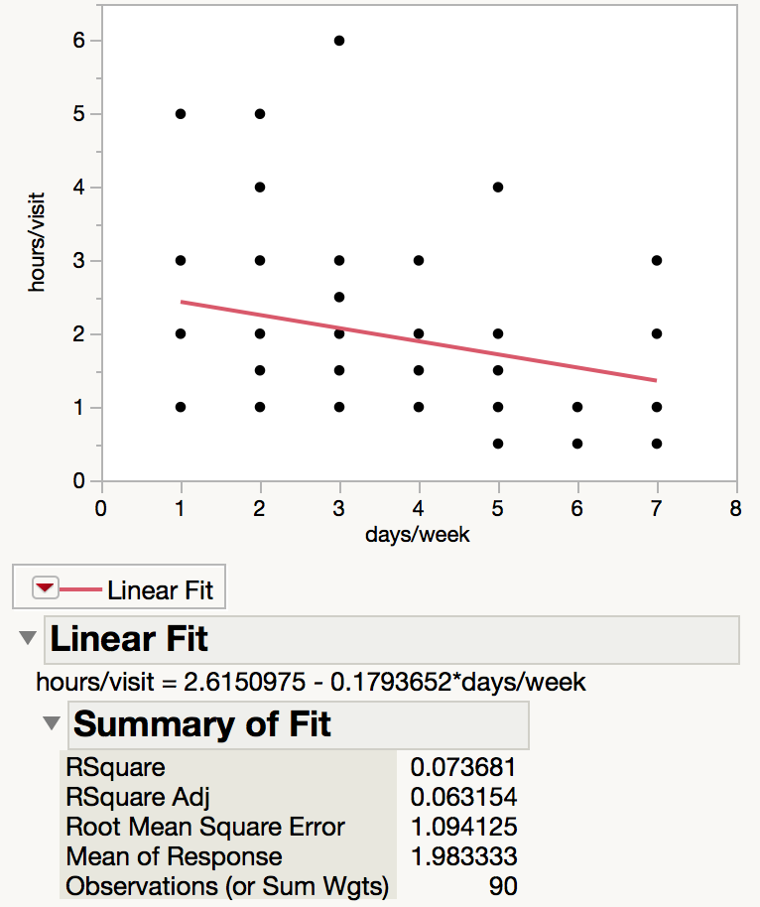

***Figure 1.*** The scatter plot displays the data collected from the sample of 90 students and shows the line of best fit, which has a negative slope obtained using JMP.

Line of Best Fit from Scatter Plot of Days/week(X) vs. Hours/visit(Y)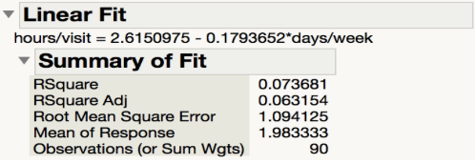

***Figure 2:*** The chart displays the key calculations from the scatter plot including the line of best fit and the RSquare obtained using JMP.

T-test for days/week(X) and hours/visit(Y)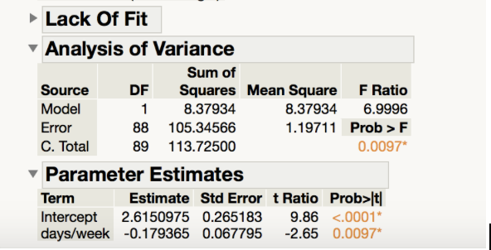

***Figure 3.*** The chart displays the parameter estimates for the t-test of days/week and hours/visits obtained using JMP.

For our analysis, we compared two variables: days/week (how many days per week a student goes to FitRec) and hours/visit (how many hours per visit do the student stay at FitRec). For these two quantitative variables, we set days/week as the x-axis and hours/visit as y-axis to produce a scatter plot (Figure 1) and the best fit line (Figure 2). From the best fit line, we can see that the two variables, Y(hours/visit) and X(days/week), have a weak negative relationship with a correlation of -0.1794. The R2 for scatter plot (0.073) is very low, showing that the variance of the data is high.

In order to further analyze or data to draw conclusions for Hypothesis 1, we performed the t-test to find the correlation between the two variables, days/week and hours/visit (Figure 3). Using y = a + bx, we determined the null hypothesis for the slope (or correlation) between the two variables as Ho: b = 0 (there is no correlation between these two variables) and the alternative hypothesis as Ha: b ≠ 0 (there is a correlation between these two variables). The results from Figure 3, which shows the t-test performed, the probability of P > |t| is less than 0.001, which is very small; therefore, we will reject our null hypothesis and accept our alternative hypothesis that there is a correlation between days/week and hours/visit at the 0.001 significance level.

**Part II:**

Hypothesis 2: Location does have an influence on how many days a student goes to FitRec per week.

Histogram for Locations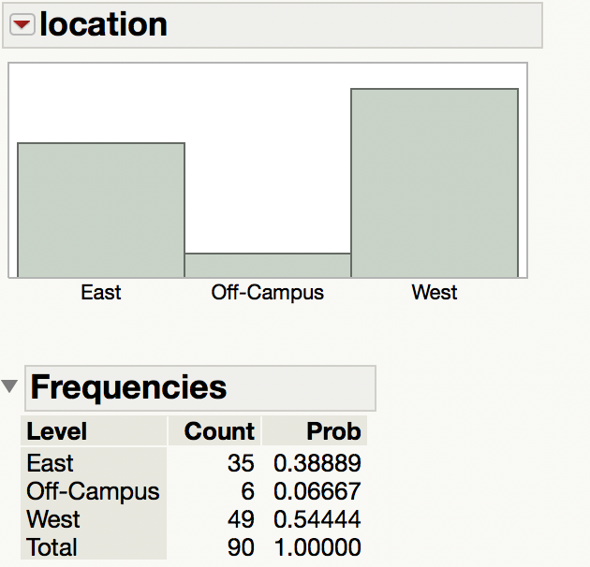

**Figure 4.** The histogram generated through JMP shows the proportion of the sampled students who live in east, west, or off-campus.

Histogram for Locations (0 = on campus, 1 = off campus)

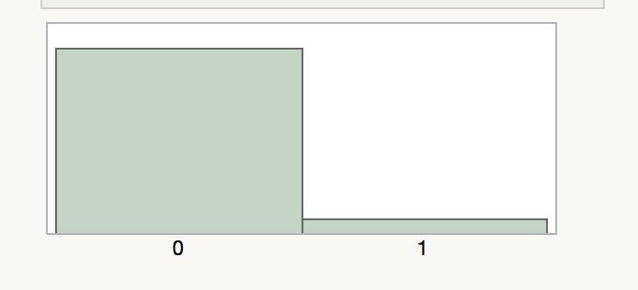

**Figure 5.** The histogram generated through JMP shows the proportion of the sampled students who live in on-campus (0) and off-campus (1).

Hypothesis Test for Location (Ho: p1&p2 = .5)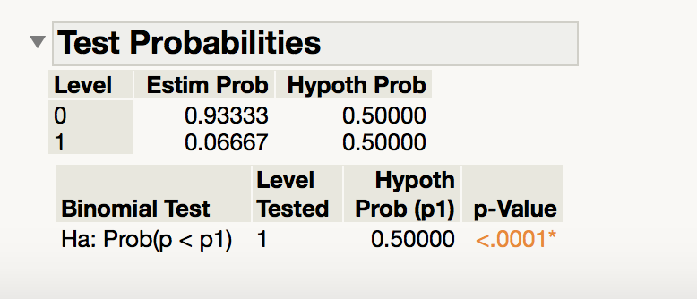

**Figure 6.** The chart displays the test probabilities calculated from the histogram with the null hypothesis that p1 = p2 (p1 and p2 both = .5) and the alternative hypothesis that p1 ≠ p2 (p1 and p2 both ≠ .5).

Test Probabilities for Location (Ho: p1= .9, p2 = 0.1)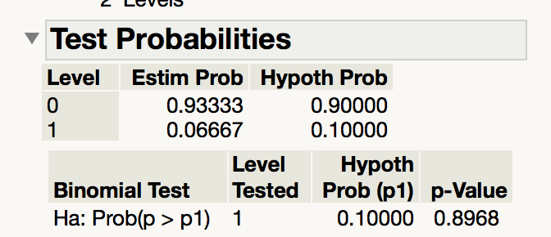

**Figure 7.** The chart displays the test probabilities calculated from the histogram with the null hypothesis that p1 = .9 and p2 = .1 and the alternative hypothesis that p1 ≠ .9 and p2 ≠ .1.

For the qualitative variables, location, a histogram was generated from our data and showed that west campus has the most students who go to the gym (Figure 4). This is expected because west campus is located closest from FitRec. However, east campus, which is far from FitRec, also has a large proportion of students who go to FitRec.

We used the hypothesis test to to find the probability (frequencies) of people who live in different locations and how often they go to FitRec. Since there are three variables: West, East, and Off-Campus, we summarized our data into two categories, on-campus and off-Campus, and used 0 for people who live on campus and 1 for people who live off campus (Figure 5). Using the “ Test Probabilities” tool, we are able to test the p-value (probability) for these two categories. To find if location has an influence on how often students go to FitRec, we assumed the probability of students who lived on-campus and those who lived off-campus that was equal. For our hypothesis test, p1 = probability of students living on campus going to FitRec and p2 = probability of students living off campus going to FitRec. Our null hypothesis was Ho: p1 = 0.5, p2 = 0.5 (p1 and p2 are equal; location does not have influence on p) and our alternative hypothesis was Ha: p1 ≠ 0.5 p2 ≠ 0.5 (p1 and p2 are not equal, meaning that location does have influence on p). Using JMP, we performed the hypothesis test and found that the the p- value is less than 0.001, so we rejected the null hypothesis that there is equal probability of students live in different locations go to FitRec center at a 0.001 confidence level (Figure 6). Thus, we can accept the alternative hypothesis which states that location does have a influence on how often students go to FitRec each week.

To further our analysis and see if students who live closer to FitRec go there more often per week than students who live further do, we performed another hypothesis test with our null hypothesis being Ho: p1 = 0.9, p2 = 0.1 (the p of students live on-campus is bigger than students live off-campus) and our alternative hypothesis being Ha: p1 ≠ 0.9 p2 ≠ 0.1(the p of students live on-campus and off-campus is not true). Using these JMP, we performed the hypothesis test and results were shown in Figure 7.Since P-value was so large (0.8968), we failed to reject the null hypothesis and were unable to accept the alternative hypothesis that there is a larger chance that people who live on campus go to FitRec more often than people who live off-campus.

**Discussion:**

From Part I, which showed the results and analysis of first hypothesis, both the line of best fit and hypothesis test of the slope of the line of best fit show that there is a correlation between two variables: days/week and hours/visit. Therefore we can conclude that hypothesis 1-- the more often students go FitRec, the less hours they spend per visit-- is valid and can be supported by the results from this sample of 90 BU students. Although the negative correlation from the line of best fit supports our hypothesis, the low R2 shows that there is high variability in the data which forces us to suspect the reliability of this conclusion. Because of the weak correlation and high variability of the data, more data must be gathered in order for us to conclude with more confidence that there is a inverse relationship between the two variables.

From Part II, which showed the results and analysis of second hypothesis, we can infer that location does have an influence on how often students go to FitRec from the histogram displaying the proportion of the population who lived in east, west, and off-campus. However, because of the large proportion of students who lived in east, which is far from the gym, went to the gym, we suspect the reliability of this conclusion. Because there was no significant difference between proportion of response of the two locations, the histogram does not offer strong support of the influence of location on how often a student goes to FitRec. In addition, from the first hypothesis test in which we tested whether or not the probability of a student who lives off campus going to Fitrec was the same as a student living on campus, we saw that p1 and p2 are, in fact, not equal, indicating that location does have an influence on how often a student goes to FitRec. However, the second hypothesis test, which tested the null hypothesis of p1 = 0.9, p2 = 0.1, showed that we do not have sufficient evidence to conclude that the the influence of location is strong as strong as 0.9. As a result, we conclude that location does have an influence on how often a student goes to FitRec, but we are unsure of how strong the influence is.

In conclusion, the study was successfully conducted and our purpose to see whether there is a relationship between days per week and location and between days per week and hours per visit has been achieved. However, more data must be gathered in order to draw conclusions with more certainty. In the future, instead of asking where a student lives on campus, we should ask specifically how long it takes to for the student to walk to FitRec. Since west, east, and off-campus are such large and broad regions, it is hard to conclude whether distance to the FitRec has influence on how often the student goes to FitRec using these categories. In addition, other factors should be surveyed and analyzed, such as major and workload, to access some other factors of why students go to the FitRec more often than others. Despite the limitations of this study, we are able to successfully conclude that location is a factor that affects how often a student goes to FitRec and that the amount of time spend at FitRec does have a relationship with how often the student goes per week. In the future, if Boston University wants to create a healthier environment for college students to avoid the “freshman 15,” they could use this study see how location affects how often a student goes to FitRec. From that, they could plan new ways for students to live healthier, such as building another facility in the eastern part of campus.

**Appendix:**

Histogram and Boxplot of Days Students Spend at FitRec per Week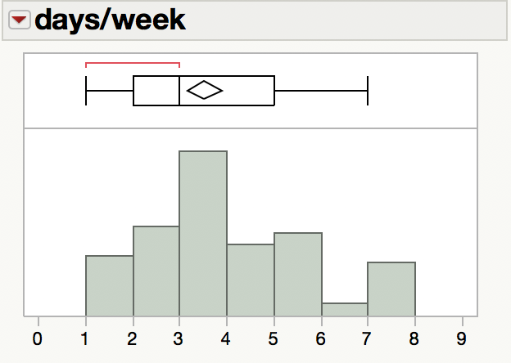

Histogram and Boxplot of Hours Students Spend at FitRec per Visit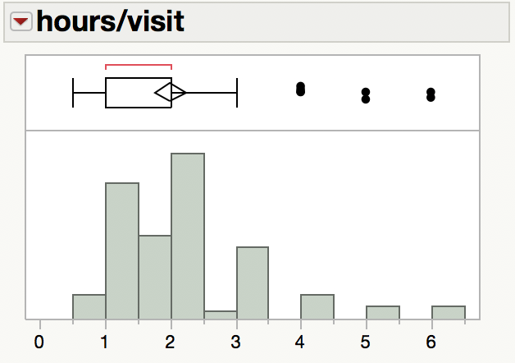

**References:**

Singer, Natasha. “15 Pounds: Part of Freshman Meal Plan?” *The New York Times*, The New York

Times, 31 Aug. 2006, [www.nytimes.com/2006/08/31/fashion/31diet.html](http://www.nytimes.com/2006/08/31/fashion/31diet.html).

Sheather, Simon J. *A Modern Approach to Regression with R*. Springer, 2010.

1. Lab write up, data analysis, graph generation (TW,YH); survey, data collection, presentation (SL,MK)